Brooklyn torah gazette
Parshas Bamidbar 5777
Volume 1, Issue 26 (Whole Number 26) 2 Sivan 5777/ May 27, 2017
Printed L’illuy nishmas Nechama bas R’ Noach, a”h

For a free subscription, please forward your request to keren18@juno.com

An Avera (Sin) Leshem Shamayim (For the sake of Heaven)?
By Rabbi Yoseph Vigler


There is a whatsapp audio going around of a radio show from many years ago. The interviewee was a famous personality involved in kiruv. A caller asked how come he was known to compromise on halacha in his quest to bring Jews closer.
He throws the question back at the caller: "If your daughter were off the derecho [not observing the Torah commandments], would you then agree to do ANYTHING to bring her back - even against halacha [Jewish law]? Well my approach has brought back many Jews to keep Shabbos, would you prefer they did NOT keep Shabbos?!"
In a nutshell, he was suggesting doing an avera [sin] for the sake of Heaven.
ANSWER: When reaching out to unaffiliated Jews, we must indeed understand where they are coming from. When Rabi Shimon bar Yochai and his son exited their cave after 12 years, they were on a very lofty level. With their spiritual powers, they were burning up simple folk who were simply not on the same spiritual height they were.
A Heavenly edict sent them right back into the cave to learn how to relate to people. So yes we too need to relate to the lives and perspectives of unaffiliated Jews.
But bending a halacha is a different story.
Did you hear about the alcoholic who recently came home drunk? He mistook the kerosene for water and took a shower in kerosene. In his drunken stupor he lit a cigarette which, unfortunately, was his end.
In 1910, at a Jewish conference, every speaker explained eloquently how the fire of assimilation was raging and something needed to be done, even if it meant compromising halacha in the process. If a fire is burning, you need to extinguish it using whatever water you can find, even dirty water.
The Rebbe Rashab [the fifth Lubavitcher Rebbe] got up and responded - all well and good if it is water you are throwing, but what if you mistook kerosene for water and mistakenly drank it?
The Mishnah says - אוהב את הבריות ומקרבן לתורה. Love everyone and bring them close to the Torah, but never bring the Torah to them. Never vice versa. Don't compromise on anything!
If you have to transgress halacha, you have not been mekarev the Yid - you just threw kerosene on his fire. You cannot bend halacha.
If it was your child, you would indeed go to the ends of the earth to be mekarev her, absolutely.
But no, never throw kerosene, never ever bend halacha chas veshalom [G-d forbid]!

Reprinted from the Parshas Emor 5777-Lag Ba’Omer email of Mayan Yisroel in Flatbush.
The Double Gift
By Rabbi David Ashear

One of the main jobs of Emunah is to train ourselves to view life's happening with the proper perspective. If a person was taken to the hospital to have a surgery for his broken leg, and during the surgery the doctors discovered a dangerous growth, and because they found it early, they were able to remove it and prevent something much worse from happening, the person would say, "Baruch Hashem for my broken leg. It was Hashem saving my life."
But one might ask, couldn't Hashem have saved his life a different way, without him having the pain and inconvenience of a broken leg? Why should he be thankful for that as well?
The answer is, every ounce of pain or affliction that a person has to suffer in this world is calculated by Hashem and given only because the person needs it, whether it's a Kapara [atonement] for him, or some other reason. And in this case, the affliction was going to happen regardless of the growth. Hashem, in His infinite kindness, made it occur at the perfect time to save the person from something else. And this way, the affliction served a dual purpose. It accomplished what it needed to accomplish for the person, and it also saved his life.
The greatest gift that Hashem could give a person is to help him fulfill his purpose in this world and bring him closer to Torah and Mitzvot. Very often, we see people going through hardship, and because of that hardship, they get closer to Hashem. But there too, we could ask, "Why did they have to suffer to get to where they are now? Couldn't it have been done another way?"
Again, the answer is the same. Every second that a person has to suffer in this world is calculated by Hashem and given because the person needs it. But at the very same time that Hashem brings a person atonement for his sins, He uses the same Kapara to benefit the person in many other ways as well. If Hashem brought it about in a way that pushed the person to become more religious, that was a tremendous Chesed.
A young Rabbi told me that almost thirty years ago, his parents had been married for a few years with no children. His mother had already had two miscarriages and was then in her sixth month, hoping for her first child. But one day she wasn't feeling well, she was taken to the hospital and the doctors determined that the baby was putting her life in jeopardy, and they needed to terminate the pregnancy immediately.
At that time, his parents were not observant at all, and his father, in desperation to have a child, made a pledge in front of all the people there. He said, "I promise, if this baby will be born healthy, I'll send him to the most religious school in our community."

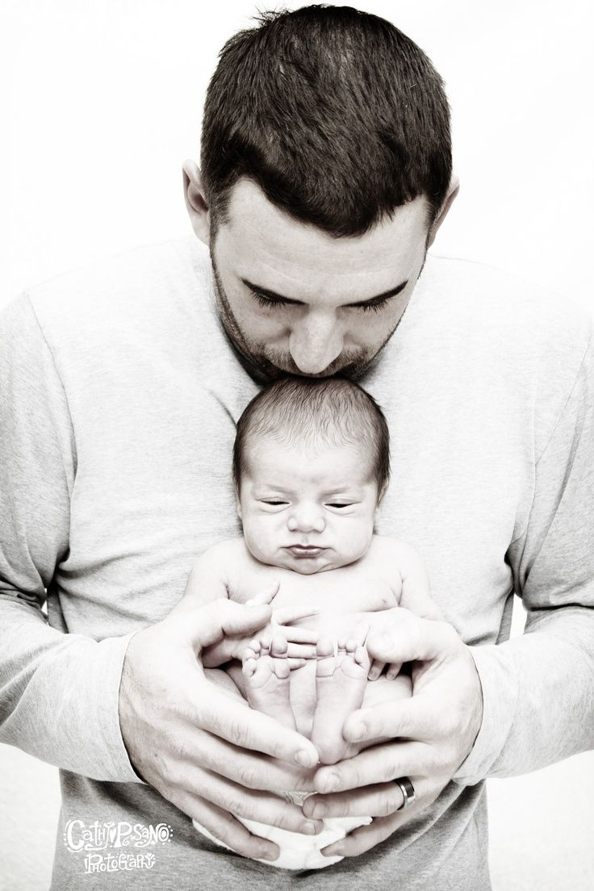

And miraculously, just a short while later, the doctors said that things had changed and the pregnancy can continue. A few months later, a healthy baby boy was born and a few years later the father fulfilled his pledge. That child eventually brought his parents closer to religion, and today they are one of the most observant of their whole community. Their baby became that Rabbi who was talking to me.
The father, who couldn't be happier with his life, got up to speak one day and said, "What looked to be the darkest time in my life turned out to be my biggest blessing." He was so thankful to Hashem for helping him come back to Him.
Hardship can come in many different forms, but Hashem, who is so kind, brings them in ways that enable us to get better and get closer to Him. This is again another aspect of Hashem's Chesed. May Hashem open our eyes to see and appreciate all His kindnesses.

Reprinted from the May 9, 2017 email of Daily Emunah.
Ambassador Friedman Has His Official Residence Kashered


U.S. Ambassador to Israel, David Friedman
Incoming US Ambassador to Israel attorney David Friedman is beginning to set up shop and for him, this includes kashering his official residence in Herzliya, not relying on the kashrus of his predecessor Dan Shapiro, who was not shomer Shabbos. Towards achieving this goal; Ambassador Friedman turned to a close friend and chavrusa, head Chabad Shaliach to the Five Towns Rabbi Zalman Wolowik. Wolowik told the ambassador that he will fly to Israel and personally see to it that the job is done.
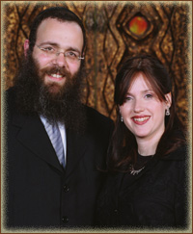

Rabbi & Rebbetzin Zalman Wolowik
Friedman tried to persuade him not to fly himself, but the rabbi was insistent, and together with his team, they arrived to the home in Herzliya Pituach and kashered the kitchen, affixed new mezuzos, and did whatever necessary so the home was ready to accommodate a frum family.
Speaking on Monday morning 19 Iyar with Noam Zeigman of Kol Berama Radio, Rav Wolowik explained “from my perspective, it was natural that I would fly and personally kasher the home and bring new mezuzos”.
Zeigman asked if there was a need to kasher since Shapiro was Jewish. Wolowik explained “I do not know the former ambassador but I can say now, the house is kosher mehadrin as per the ambassador’s standards”.

Reprinted from the May 16, 2017 website of Yeshiva World News.

The Last Years of Dona Gracia Mendes (1564-1569)
By Rabbi Yosef Bitton

In 1558 Dona Gracia Mendes offered to the Turkish Sultan Suleiman the Magnificent to rebuild the city of Tiberias [in the Holy Land], which was practically in ruins. The Christians did not live there nor pretend it and the Muslims had no claim for it. Beyond the occasional presence of certain Bedouin nomads, Tiberias was a ghost town, in a total state of neglect, where chaos and vandalism reigned.
Dona Gracia, her nephew Yosef Nasi and Rabbi Yosef Ben Adrete, began to revitalize the city, to beautify it, to develop industries and to bring investors, to make Tiberias an autonomous city where Jews dispersed throughout the world could come and live in peace.
However, in 1564, when the wall was erected and the Yehudim began to return to Israel, suddenly the city of Tiberias, began to be claimed by Christians and Muslims.
As Andrea Aelion Brooks explains in her book on Dona Gracia Mendes, "The Woman Who Defied Kings", the problem was not that Muslims and Christians suddenly fell in love with Tiberias. The problem was that "the Jews" were rebuilding it and planning to have an autonomous city-state there.
As is the case today with Medinat Israel, the grievances of Israel's neighbors are not political but religious in nature. Both Christianity and Islam consider themselves as the heirs of the Jewish People who should have disappeared long ago. In the 1560’s a Muslim sheik began to spread the word that he had found an ancient prophecy where it was stated that if the Jews rebuilt Tiberias “our faith (the Muslim faith YB) will be lost and we will be found wanting.”



And although the Sultan Suleiman, who was a great defender of the Muslim faith, had given his blessing for the establishment of the Jews to Tiberias, these malicious rumors were enough to inflame the mood of the local Muslim population and things began to become more difficult for the Jews who arrived there.
The Christian world saw with even less approval that the Jews planned to establish an independent city-state, much less in the "Holy Land". For Christianity, which failed to explain theologically the stubborn survival of the Jewish people despite having done everything possible to avoid it, the exile of the Jewish people, and its status as a pariah and wandering nation, was the eternal divine punishment for the crime of deicide (killing of a god. sic!) committed by the Jews (sic!) in the times of Yeshu.
Therefore, the idea of the return of the Jews to Israel and the establishment of their own state represent a theological nightmare that would shake the fundamental dogma of Christianity: the replacement theory. That is why in 1563, when the French consul of Constantinople learned of the plan to re-establish a Jewish State, he wrote to his superiors in alarm, saying (falsely) that Tiberias would be established as a city "exclusively" for Jews.
This argument was false, and more importantly, incredibly cynical, since in the middle ages the Jews who did not convert were expelled from all the countries of Europe because "only Christians were allowed to live there." Andrea Aelion writes that: "The idea that the Jews would regrouping as a nation, even an embryonic one, seemed to horrify the Christian world.”
Although Sultan Suleiman continued to support this project, the Jewish colony in Tiberias did not prosper in the long term. In 1565 Suleiman had too many problems related to his succession and in 1566 he passed away while in a military expedition to Hungary. Without the support of Suleiman and with the battle of the succession in full, the project of Tiberias was debilitated politically. And the political chaos in Constantinople was reflected quickly in Tiberias, where in spite of the walls, the vandalism of the Bedouin tribes and local Arabs was becoming more and more violent.
Dona Gracia, as we explained yesterday, had begun to build her house in Tiberias, but never reached Erets Israel. Perhaps because she was ill or perhaps because she thought that from Constantinople she could exert a greater influence to continue maintaining and reinforcing the incipient Jewish colony in Tiberias.
In 1569 Dona Gracia Mendes, now called by her original Jewish surname: "Nasi", left this world at the age of 59.

(Writer’s Note: I think it is a great historical injustice that the name, life and work of this incredible ESHET HAIL is so little known. Knowing her history, in my opinion, is not only important to honor her memory but mainly to learn from this virtuous woman how we should do our best efforts and use all our means and resources to help Am Israel in the best way possible. YEHI ZIKHRAH BARUKH May her memory be for us a model and inspiration!)

Reprinted from the May 16, 2017 Halakha of the Day email of the Shehebar Sephardic Center.
Landlord Busts Tenants for
Swiping Mezuzahs from Neighbors
By Kathianne Boniello


120 W. 97th St. (Courtesy Google Photo)

The mystery of the missing mezuzahs is solved for one Manhattan landlord, who claims a pair of tenants have been terrorizing their Upper West Side neighbors.
Tanya McLeod and Anthony Bullock have allegedly been swiping mezuzahs from their neighbors’ apartment doors at 120 W. 97th St., according to court papers.
The landlord wants to boot McLeod and Bullock, who have allegedly repeatedly knocked on doors in the building “during all hours of the day and night begging for money.”
They’ve also become a nuisance next door, stealing mezuzahs — a parchment inscribed with verses from the Torah, contained in a small box at the doorway of a Jewish home — from 160 W. 97th St. as well, the landlord said in its Manhattan Supreme Court lawsuit.
The landlord evicted the pair last month but they ignored it. McLeod and Bullock could not be reached.

Reprinted from the May 14, 2017 edition of the New York Daily News.
Video Cameras and
Cholov Yisroel
By Rabbi Yair Hoffman



Many have posed the question: Why can’t we have video cameras at the supplier dairies to make more food Cholov Yisroel? The feed could go straight to some office where Jews are standing and watching. It could be done throughout Israel and in a good many places in the United States Imagine the possibilities: Coffee anywhere, Hershey’s, Haagen Daas, Entemanns.
Not many people are aware of this, but New York City is filled with video cameras that have license plate readers. These readers are hooked up to a central computer system. Indeed, almost every police car in New York City is equipped with such a camera. It is only a matter of time when teh Kashrus agencies will go to the dairy suppliers of the companies under them and install cameras to make it Cholov Yisroel.
This author predicts that there will be an American kashrus agency that will start offering this service to the dairy suppliers of companies within the next two or three years. The issue, however, is a machlokes among recent Gedolei haPoskim. Dayan Yechezkel Roth, shlita (Emek HaTeshuvah IX #85) forbids it as does Rav Moshe Shternbuch (Teshuvos v’Hanhagos V #255). Rav Elyashiv zt”l (Nesiv HaChalav 3 p.29) and Rav Vosner zt”l (Journal Ohr Yisroel Tishrei 5772 Gilyon I p.29), however, both permit it.


Photos of cows being automatically milked in the United Kingdom.

There is a caveat that the monitor must always be watched. This is even according to the lenient view.
Those that are stringent and forbid it, do so for a number of reasons – among which is the fact that the tape can easily be forged. Another reason is that people do tend to slack off when no one is accountable. The main reason is that they understand that Chazal forbade the milk when the Jew was not physically present.

Reprinted from the May 16, 2017 website of Yeshiva World News. Originally printed in the Five Towns Jewish Times.

Historic Shul in Lower East Side Destroyed By Fire

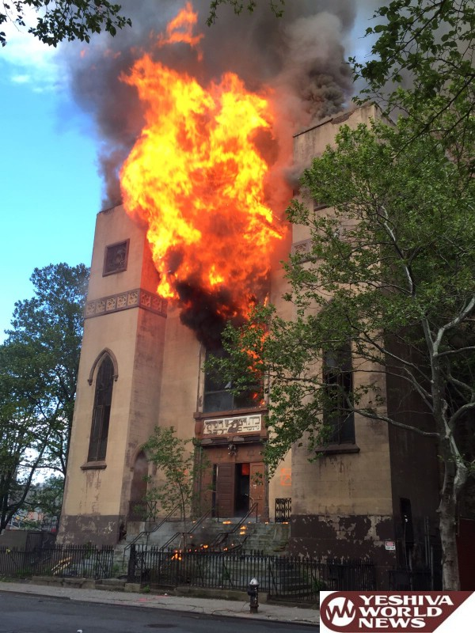

Firefighters battled fire at a historic Shul in lower Manhattan Sunday [May 14th] evening that sent smoke billowing across the skyline.
The blaze began at 60 Norfolk Street in the Lower East Side around 7:00PM at the “Bais Medrash Hagadol”. It quickly grew to a 3-alarm fire inside the abandoned building, according to the FDNY. The fire was placed under control less than three hours later.
This Shul was founded in 1852 and was said to be the oldest Russian Jewish orthodox one in the United States until it was abandoned ten years ago.
WPIX reported that the structure was landmarked, but there had been a recent move to demolish the structure to turn it into condominiums.
The good news is that the synagogue was vacant for a decade, and no one was injured. Firefighters were faced with challenges, though. They arrived at the scene within four minutes, but they had to quickly pull out from inside.
“The roof collapsed, so we mounted an exterior attack, so the whole operation was an exterior attack,” says Assistant Chief Thomas Mckavanagh.

Reprinted from the May 14, 2017 website of Yeshiva World News.

The Supremacy of the Torah
By Rabbi Moshe Meir Weiss



The posuk describes the pursuit of Torah study as being, “Yikara hi mipninim – More precious than pearls.” Homiletically, the Gemora interprets this posuk to mean, “M’kohein godol hanichnas lifnei u’lifnim, that the study of Torah is more precious than the High Priest who enters the Holy of Holies.
This is an extraordinary statement. We must understand that the Kodesh Kodoshim, the Holy of Holies, is the holiest place on earth. It is entered only on Yom Kippur, the holiest day of the year, and only by the Kohein Gadol, who is arguably the holiest person on earth. And yet, the Gemora categorically tells us that when one sits down to study Torah, it is a greater activity than the Kohein Gadol entering the Holy of Holies on the Day of Atonement.
We should not be surprised, however, when hearing such grandiose descriptions about Torah study for the Gemora in Megillah also teaches us, “Gedolah Talmud Torah yoseir mei’hatzolos nefoshos – Greater is Torah study even more than saving a life.”
Now, don’t misunderstand this Talmudic dictum. If you are sitting and learning Gemora and you see someone drowning and you say to yourself, “I can’t be bothered to save that person – It’s bitul Torah, it’s taking time away from Torah study,” you are a chosid shoteh, a pious fool, and you’re guilty of felonious behavior. What it does mean is that in raw merit, time spent in learning Torah has more Eternal value than saving a life.
This is why Mordechai was demoted in the ‘pecking order’ of the leadership of the Anshei Kneses HaGedolah from the rank of four to the rank of five when he got involved in the political intrigue to save Klal Yisroel during the days of Purim. For, although he saved the Jewish people, he would have had even more merit if he had been able to learn instead.
Think how incredible that is. You have two people who spent their Sunday night from 8 to 9 p. m. One administered the Heimlich maneuver and saved a person from choking and another person attended the Daf Yomi. In the scales of merit, it is the latter person who comes out on top.
That should give us a whole new perspective on how to prioritize our time. Or, as the Chofetz Chaim, Zt”l, Zy”a, put it, if you saw somebody having a massive heart attack and you didn’t react on time to call Hatzalah and he died before your very eyes, you would rue that day for the rest of your life. So that’s the way you should feel, and more, when you have a whole Sunday ahead of you without anything pressing to do and you don’t spend any of that precious time on the study of Torah. If you would rue the inability to save the life, then your inability to spend time learning Torah, which is even more precious than saving a life, should certainly distress you to no end.
As we count sefira, and declare nightly our longing and our appreciation of the national treasure of Torah which has been given only to us, may we concretize our sefira declaration by making more use of our daily time for the greatest of all occupations, and the very purpose of the creation of the world, which is Torah study. In that merit may Hashem bless us all with long life, good health, and all Torah blessings.
Please learn and daven for the refuah sheleima of Miriam Liba bas Devorah, b’soch shaar cholei Yisroel.

Reprinted from the Parshas Emor 5777 website of THE VUES.

